

**SCM 518 – Analytical Decision Modeling**

**Final Project Report**

**Optimizing Woodman’s Grocery Delivery**

**Dr. Yimin Wang**

Arizona State University

W. P. Carey School of Business

**Submission by Team 14 Cohort D**

Kumar Adavelly

Anjana Ganesh

Kenny Tjong

**INTRODUCTION**

The major objective of optimization modeling is to enhance a complex business problem by breaking it down to three characteristics- an objective function, decision variables and business constraints. This helps in solving the problem and analyzing the solution that is most optimal given the constraints and decisions we are to make.

Analytical Decision-making focuses on structuring, analyzing and solving business problems. We address problems of resource allocation (Optimal resource usage), risk analysis (Simulate uncertainty), decision analysis (analyze decisions with problems), data analysis (Synthesizing data) and forecasting (Extrapolate past observations).

Industries, specifically the retail industries are going customer-centric today. By introducing more features and services they wish to attract more customers, and in turn maximize their profit.

**OBJECTIVE**

In this problem, we are trying to optimize the delivery services of a local grocery store named Woodman’s which is located in Madison, Wisconsin. Such real time situations help in visualizing what are the day-to-day problems a business could face and how decision modeling with optimization can prove to find a useful solution

Currently, the store uses their own delivery vehicles and drivers to accommodate their customer’s orders. We suggest changes to this grocery store such that their customer’s demands are met along with an optimal delivery strategy.

The main purpose of this problem is to optimize how Woodman’s can make use of ridesharing vehicles to support their delivery fleet and to develop a model that routes both the supermarkets vehicles and the ridesharing vehicles to satisfy customer demands.

**PROBLEM VISUAL VIEW**

This problem can be modeled as a Heterogeneous Fleet Vehicle Routing Problem with Time Windows (HVRPTW).

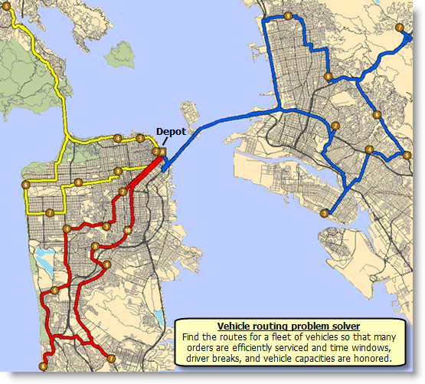

*Fig.- Map showing the route feasibility*

The problem can be viewed as the map above which shows how we use the supermarket’s vehicle or the rideshare vehicle to meet customer’s everyday demands. An optimal and cost-saving route has to be designed such that the store can run a trip wherein it accommodates multiple customer’s needs (if any) and also supports variable customer demand (measured in cartons).

**TOOLS USED**

This problem had multiple factors to be taken into account. A cost-optimal route had the distance, number of customers to be served in that route, the vehicle capacity and the time constraints.

The following tools were used in this optimization problem-

1. Google distance matrix API on Python
2. Open Solver

The Google Distance Matrix API is a service that provides travel distance and time for a matrix of origins and destinations. We use this to calculate the distance that needs to be served from the grocery store to the customer’s location.

An initial trial of solving the problem was attempted using the Gurobi optimization solver of Python. But due to its non-familiarity and complexity, the problem was implemented using Open Solver.

Since we are dealing with a larger count of variables (Here, a 1000 variables), the in-built Excel solver could facilitate only up to 200 variables. Open solver is an extension to the in-built solver which helps in more powerful optimization by supporting larger and complex Integer and linear problems.

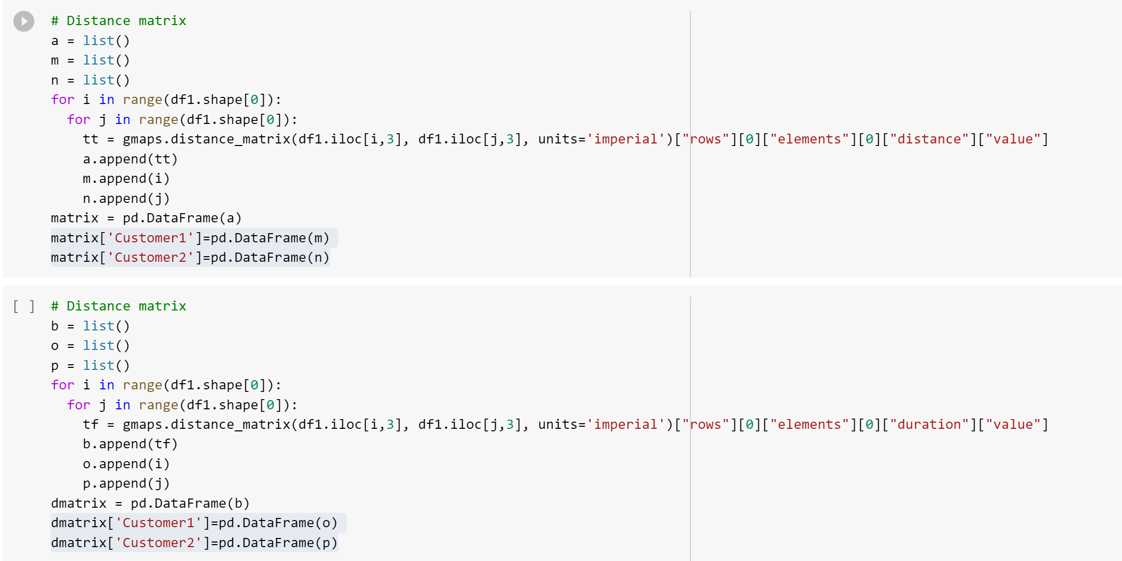

*Fig.- Distance matrix using Google API*

The following snapshot explains how distance matrix is calculated with Google Distance Matrix API. The API returns information based on the recommended route between start and end points, as calculated by the GoogleMaps API, and consists of rows containing duration and distance values for each pair.

This problem has taken 9 customers and their demands respectively along with 2 classes of vehicle support. They include, Woodman’s own delivery vehicle and the ridesharing vehicle is the Uber service.

|  |  |
| --- | --- |
| Customer | Demand |
| 1 | 4 |
| 2 | 6 |
| 3 | 3 |
| 4 | 1 |
| 5 | 3 |
| 6 | 4 |
| 7 | 5 |
| 8 | 5 |
| 9 | 1 |

Also, for the simplicity of solving this problem, we have taken the following considerations –

|  |  |  |
| --- | --- | --- |
| **Factors** | **Woodman's** | **Uber** |
| Maximum number of Vehicles | 3 | 2 |
| Vehicle Capacity in cartons | 30 | 10 |
| Cost per mile | $1.38 | $1.85 |
| Average vehicle speed in meters | 48280 | 48280 |
| Time to serve customers in secs | 300 | 300 |
| Cartons at each customer location | Depends on customer demand | |
| Cost of refusing delivery | $50 |  |
| Time window for deliver in secs | 3600 | 3600 |

*Fig.- Model assumptions*

Following are the list of factors that we have taken for setting up the optimization model -

The major deciding factor here would be to choose an optimal route that is serviced by a type of vehicle (either the supermarket’s vehicle or the rideshare) and to also to decide if a particular customer is serviced in that route.

The cost of this entire process should be minimal, the reason for which we choose a ridesharing vehicle in servicing a few customers.

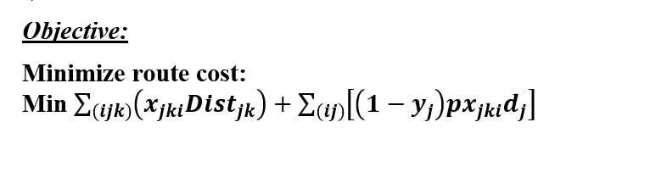

Some of the constraints that the problem handles are –

1. Valid routes are to be constructed with no infeasibility
2. Each route starts and ends at the depot (Woodman's grocery store) and can be completed by a store-owned vehicle or by a rideshare vehicle
3. Customer demands are variable and accordingly we may choose to service them with either of the vehicles
4. Vehicle capacity restrictions- A rideshare vehicle can’t handle more goods but a store-owned vehicle may be designed to handle a particular load
5. Time window constraints- customer orders are delivered by a single vehicle. In this problem, we assume a 3-hour time window where the order and services are met within that time frame. In real world cases, this could purely be subjective

**RESULTS AND CONCLUSION**

The output analysis mainly looks for the cost that was minimized at the end of the day using this strategy which could be compared to the previous cost that the grocery store had in servicing their customers.

Following snapshot describes the overall model setup of optimizing this problem -

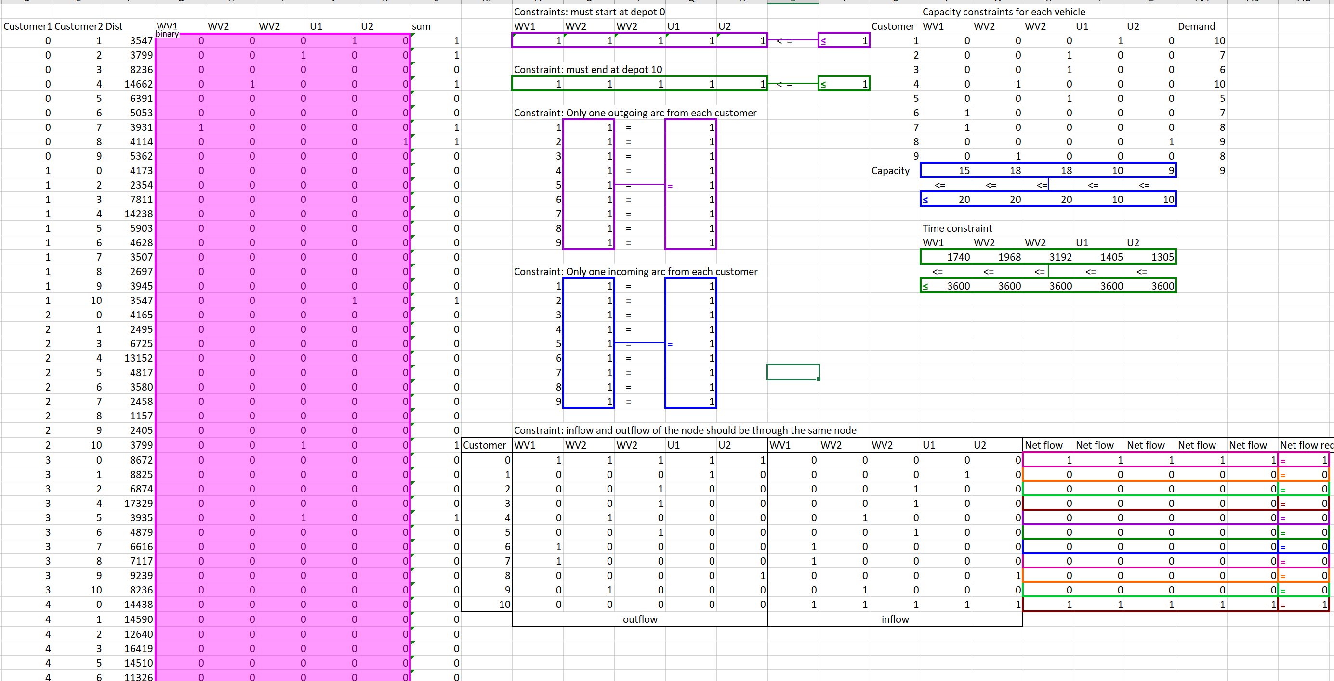

*Fig.- Model Setup using Excel*

The setup explains the demand that has to by taking into account the distance of the customer’s location from the grocery store. It also shows the net inflow and outflow of serving them after accepting each order. The vehicle capacity constraints are also considered before arriving at a decision which is expressed in the capacity matrix. Also, it considers the servicing of a customer by only one vehicle which is shown by the incoming and outgoing arc (i, j arc of meeting customer demand). Finally, the 3-hour time window is also shown for each vehicle which explains that the service is met within the time constraint.

Below is the output which describes the binary decision of serving the 9 customers with their respective demands and the overall cost that was obtained at the end of each day with the new strategic model.

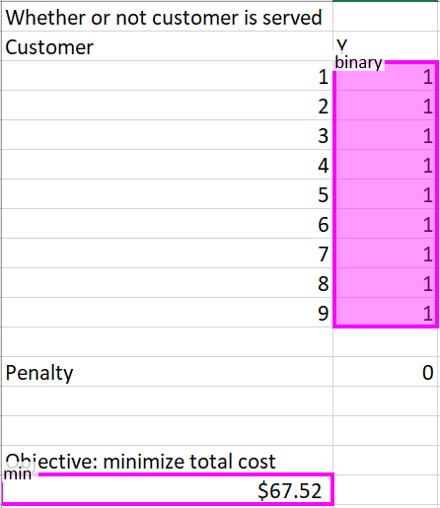

*Fig.- Cost optimization*

Hence, we recommend Woodman’s to use this optimization strategy to serve their customer’s demands such that they maximize their customers and also find a feasible way to serve them by not incurring high costs.

**Appendix**:

**Base Model:**

***Parameters:***

= Maximum number of vehicles

= Maximum capacity of vehicle

= Cost per mile using vehicle

= Time to serve each customer (5 min)

= Cartons demanded by customer

= Distance from customer location to customer location, where is all feasible solutions ,

location of supermarket

location of supermarket

= Penalty for refusing one carton of delivery

= Time within which to deliver to each customer

= Travel time from customer j location to customer k location, where is all feasible solutions ,

***Decisions:***

= Whether or not arc , is travelled by vehicle type

, ,

= Whether or not customer is served,

***Objective:***

Minimize route cost:

Min

***Constraints:***

1. ,

Must start from supermarket

1. ,

Must end at supermarket

1. , ,

Only one outgoing arc from each customer

1. , ,

Only one incoming arc for each customer



Connectivity maintenance constraint

1. , ,

Vehicle Capacity Constraint



, ,

Time Constraints

Binary Constraint